|  |  |
| --- | --- |
| **Sony Alpha A6400 Camera**  Máy ảnh Sony Alpha A6400 (Black) + Lens E 18-135mm F3.5-5.6 | Chính hãng  Sony Alpha a6400 + kit 18-135mm  Chính hãng.3 Sony Alpha a6400 + kit 18-135mm  Chính hãng.1 Sony Alpha a6400 + kit 18-135mm  Chính hãng.4 Sony Alpha A6400.5 | **Featured information:**   * Full-frame 24.2MP sensor * ISO range: 100 - 32000 (expandable 100 - 104200) * Resolution: 24.2MP * Wireless connection: WiFi, bluetooth   Price : 1000$  **Specifications:**   * **Sensor Format:** APS-C (1.5x Crop) * **Resolution:** 25 megapixels * **Size photo:** 6000 x 4000 * **Image Proportions:** 3:2, 16:9 * **Sensor Type:** CMOS * **Image Format:** JPEG, Raw * **Anti-Vibration:** Yes * **Lens Mount:** Sony E |

**Description:**

#### **Fast Hybrid AF focusing technology**

Focusing during movie recording is fast and stable thanks to upgraded Fast Hybrid AF technology, keeping the subject in focus smoothly, even when a subject passes in front of the camera. This advanced touch AF functionality makes it a suitable camera choice for many vloggers and video creators who regularly create and upload online content.

#### **Design of Sony A6400 ( ILCE-6400 / ILCE-6400L / ILCE-6400M )**

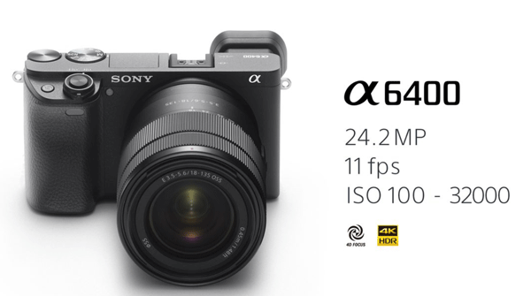

The autofocus system on the Alpha a6400 (ILCE-6400 / ILCE-6400L / ILCE-6400M) inherits many technologies from Sony's full-frame camera lines, including the A9, A7R III and A7 III models. The A6400 has 425 phase-detection AF points and 425 contrast-detection AF points densely placed across the entire image area, accounting for about 84% of the image area.

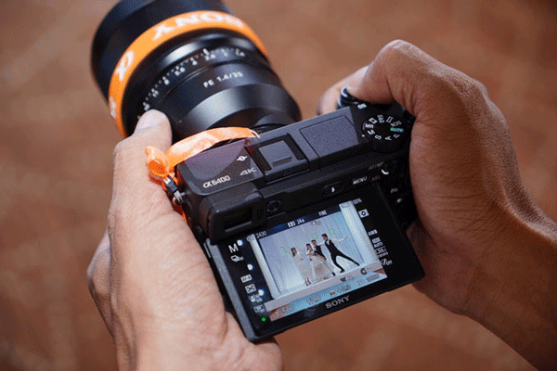v